# 

**LION INTERNATIONAL BANK**

**telebirr Merchant User Manual**

Contents

Login to System 3

Request Transaction Request 4

Approve Transaction 8

Print Receipt 9

# Login to System

To access the system, please use valid credentials at the following URL:   
**URL:** <http://10.1.10.106:8484>

1. Enter your username.
2. Enter your password.
3. Click on the "Login" button.

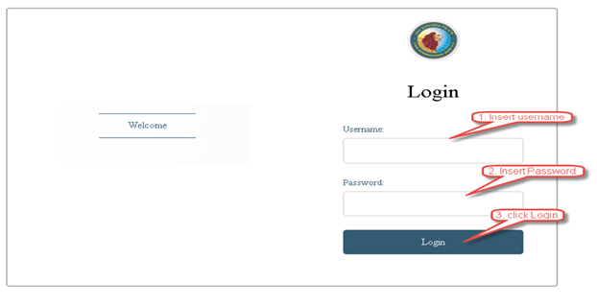

# Request Transaction Request

1. User login with maker account.
2. Select “telebirr request” from the left side menu.
3. Enter merchant short code then click search.

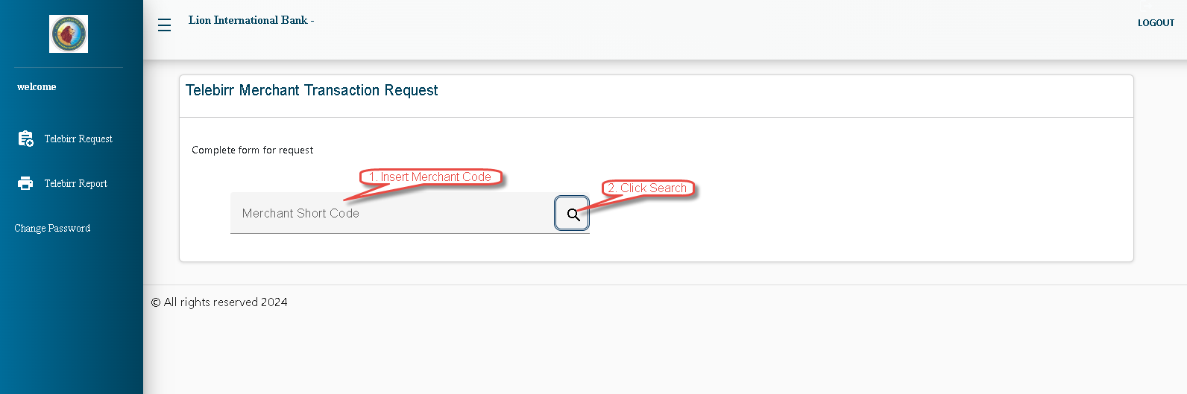

1. Merchant name will Displayed.

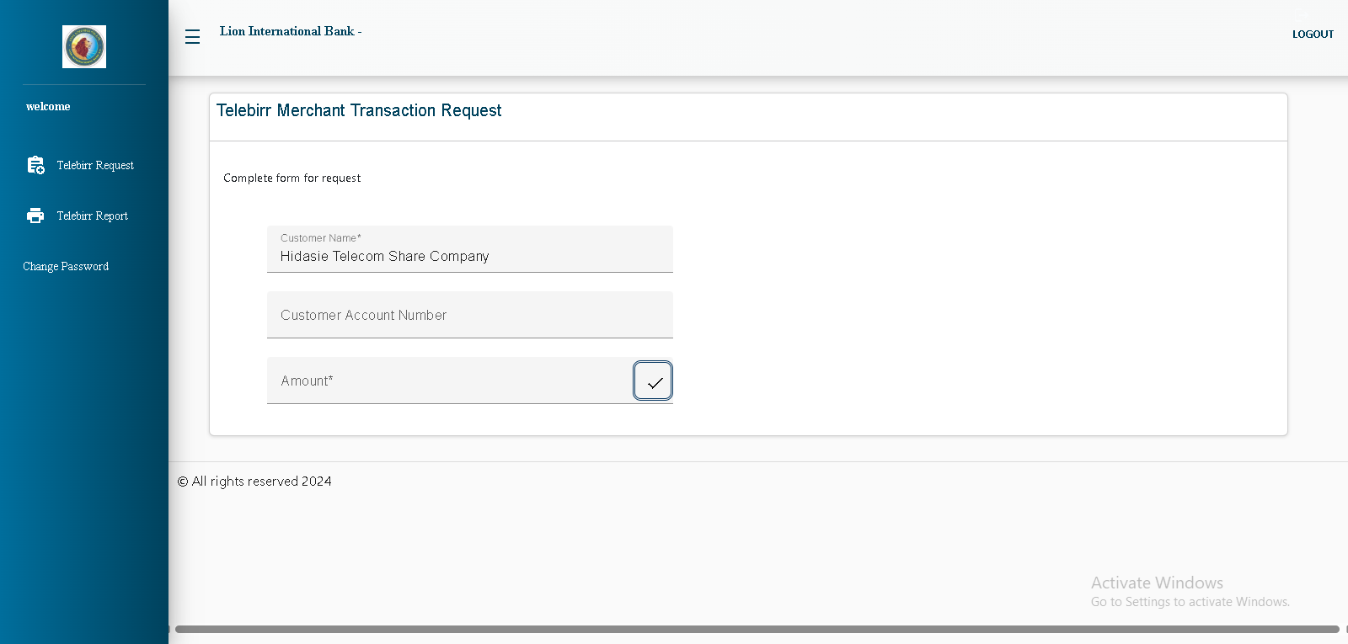

1. Insert LIB Account for transfer.

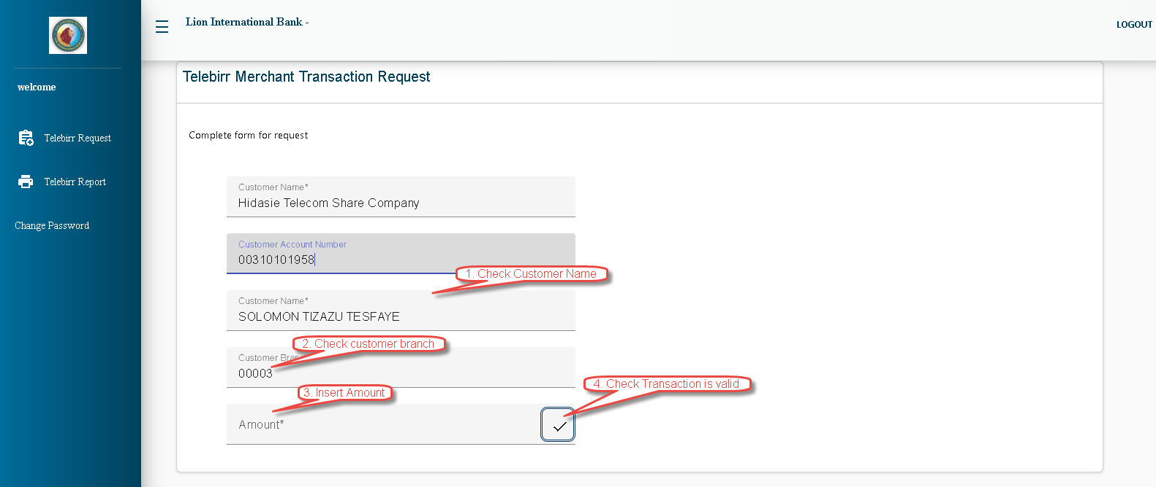

1. Enter the transfer amount and then click the check button.
2. If the account is eligible to transfer the specified amount, click Submit to initiate the transaction request.

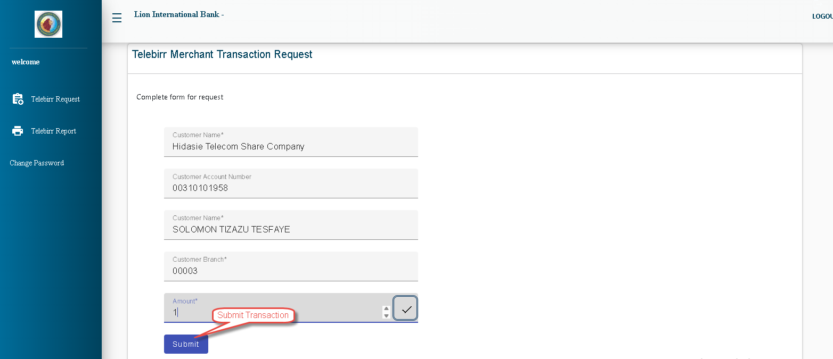

# Approve Transaction

Checker Will Approve the requested transaction.

1. The user login to the system.
2. Select “telebirr approval” from the left menu.
3. Search the transaction by date and account.
4. Click “approve” or “reject” button.

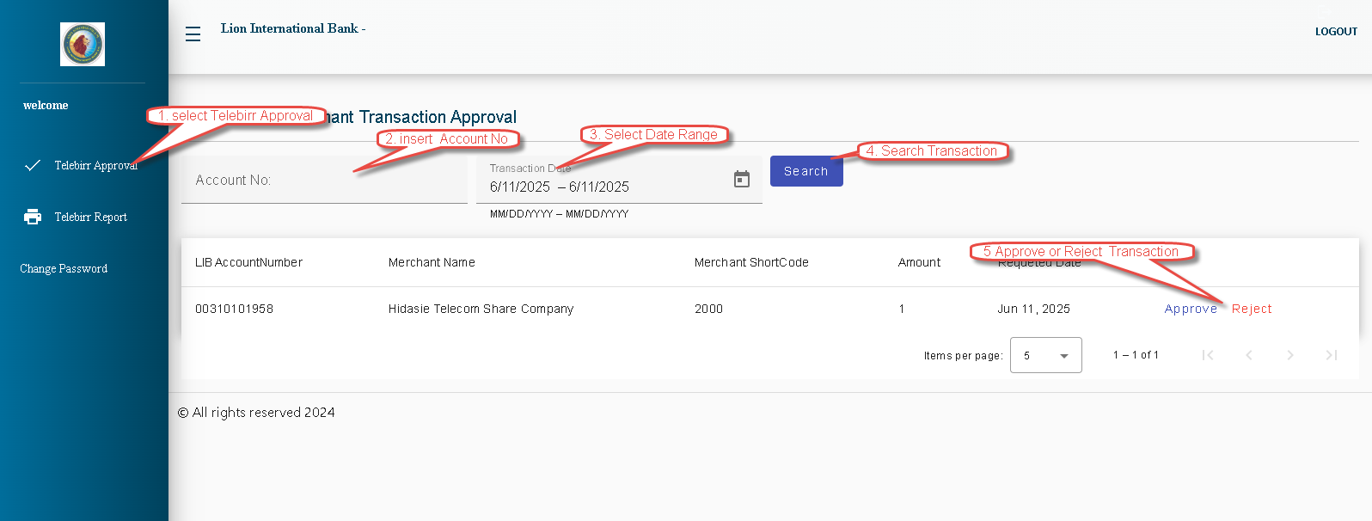

# Print Receipt

1. User login to the system.
2. Select “telebirr report” from the left menu.
3. Search the transaction by date and account.
4. Click print button

